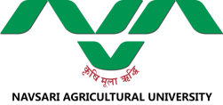 | FUTURE PLAN  Food Quality of Testing Laboratory  N. M. College of Agriculture  Navsari Agricultural University, Navsari (Gujarat) | 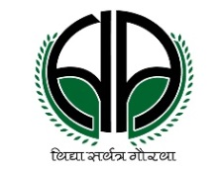

Food Safety
A) Food Microbiology
- Food borne pathogen in region specific food by using state of art technology
- Survey and surveillance of status of mycotoxins in different raw and processed food
- Study on identification and phenotypic characterization of microflora isolated from various local sources
- Evaluation of nano-technological and biotechnological interventions in food safety
B) Chemical food Contaminants and adulterants
- Status of pesticide residues, veterinary drugs, POPs and EDCs from different raw and processed imported or locally produced food items farm produce
- Determination of persistence, environmental and human risk assessment of recently introduced plant protection molecules
- Status of synthetic food colours in marketable finished food products
- Study on food processing contaminants and unapproved food additives and adulterants
- Assisting the organic food producer for the analysis of pesticide residues and other prohibited chemicals in organic farming
C) Elemental and biochemical profiling
- Study on biochemical and elemental profiling of marginalized horticultural crops of the region
- Determination of the bio-active compounds in horticultural, medicinal crops as well as microbes
- Starts the work on metabolomics of volatile compounds, flavours and fragrance in sample of vegetal and animal origin

