Technology developed

1. Technology developed

Sugarcane breeding
    - Sugarcane early maturing clone was identified for release in Peninsular Zone of the country. (Ref.F.No.31-5/12-PCS of Dr. O. K. Sinha, PC, Sugarcane).
# CoN 05071 (Gujarat Sugarcane – 5) (2012)

Particulars | Characteristics
Parents | CoJn 86310 X Co 86249
Cane Yield (t/ha) | 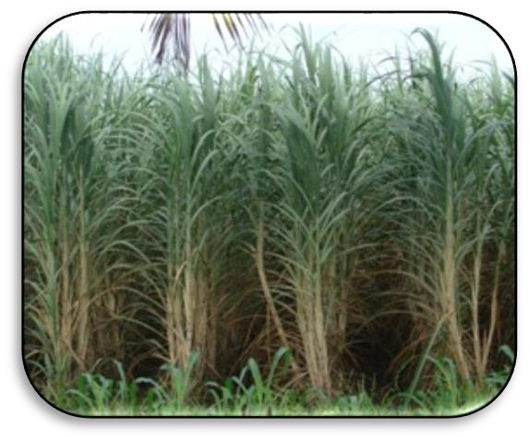  142.78
Sugar yield (t/ha) | 18.86
Sucrose % Juice | 18.67
Disease reaction | Red rot: MR Wilt: MR Smut: R

Sugarcane Variety Released for general cultivation for farmers of Gujarat (Released through State Seed Sub Committee)
- CoN 03131 (Gujarat Sugarcane – 4) (2005)

 | Particulars | Characteristics
 | Parents | Bo 108 X CoS 510
 | 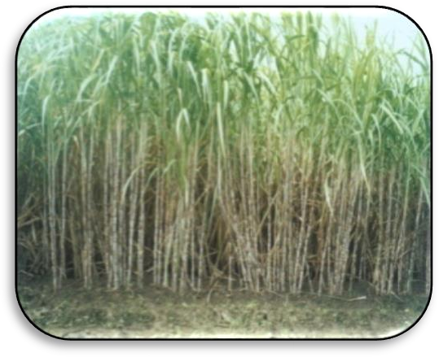  Cane Yield (t/ha) | 145.74
 | Sugar yield (t/ha) | 18.98
 | Sucrose % Juice | 18.55
 | Disease reaction | Red rot: MR Wilt: MR
- CoN 05071 (Gujarat Sugarcane – 5) (2007)

Particulars | Characteristics
Parents | CoJn 86310 X Co 86249
Cane Yield (t/ha) | 142.78
Sugar yield (t/ha) | 18.86
Sucrose % Juice | 18.67
Disease reaction | Red rot: MR Wilt: MR Smut: R

- CoN 05072 (Gujarat Sugarcane – 6) (2007)

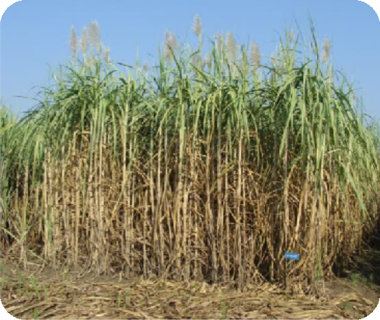 | Particulars | Characteristics
 | Parents | Co 8213 X BO 91
 | Cane Yield (t/ha) | 134.89
 | Sugar yield (t/ha) | 16.88
 | Sucrose % Juice | 17.68
 | Disease reaction | Red rot: R Wilt: R  Smut: R

- CoN 04131 (Gujarat Navsari Sugarcane – 7) (2011)

Particulars | Characteristics | 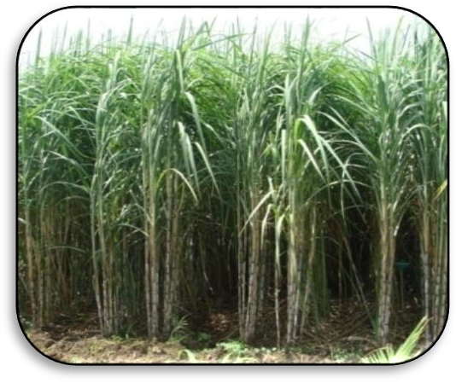
Parents | Co 95021 X Co 8347
Cane Yield (t/ha) | 134.74
Sugar yield (t/ha) | 17.06
Sucrose % Juice | 18.13
Disease reaction | Red rot: MR Wilt: MR Smut: R
- CoN 07072 (Gujarat Navsari Sugarcane – 8) (2013)

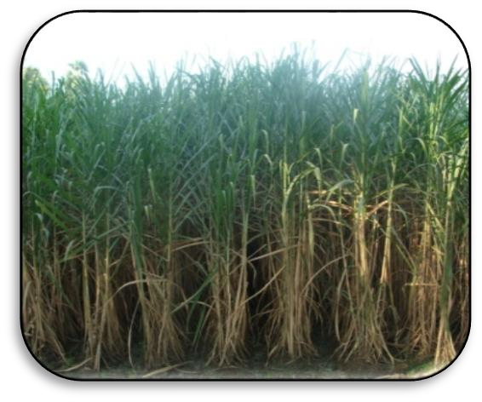 | Particulars | Characteristics
 | Parents | CoS 8436 X Co 86002
 | Cane Yield (t/ha) | 136.06
 | Sugar yield (t/ha) | 17.89
 | Sucrose % Juice | 18.50
 | Disease reaction | Red rot: MR Wilt: MR  Smut: R

- CoN 09072 (Gujarat Navsari Sugarcane – 9) (2015)

Particulars | Characteristics
Parents | Co 0217 G.C.
Cane Yield (t/ha) | 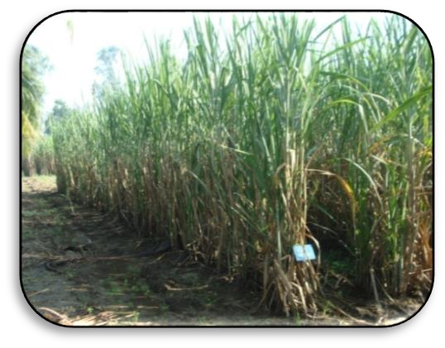  129.05
Sugar yield (t/ha) | 16.15
Sucrose % Juice | 18.00
Disease reaction | Red rot: MR Wilt: MR  Smut: R

- CoN 13073 (Gujarat Navsari Sugarcane – 10) (2017)
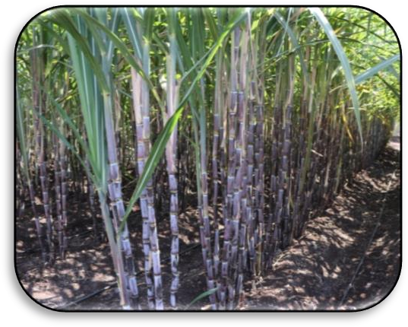 | Particulars | Characteristics
 | Parents | CoN 91132 X CoC 671
 | Cane Yield (t/ha) | 138.85
 | Sugar yield (t/ha) | 18.03
 | Sucrose % Juice | 18.53
 | Disease reaction | Red rot: MR Wilt: MR  Smut: R
- CoN 13072 (Gujarat Navsari Sugarcane – 11) (2018) (Navya)
Particulars | Characteristics
Parents | Co 86032 G.C.
Cane Yield (t/ha) | 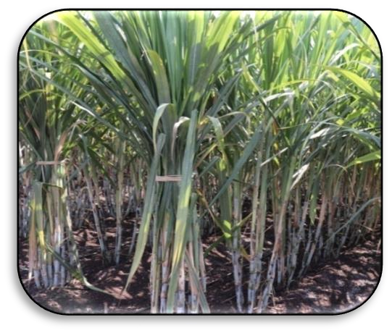  132.53
Sugar yield (t/ha) | 17.86
Sucrose % Juice | 19.11
Disease reaction | Red rot: MR Wilt: MR Smut: R
- CoN 15071 (Gujarat Navsari Sugarcane – 12) (2021) (Divyashi)
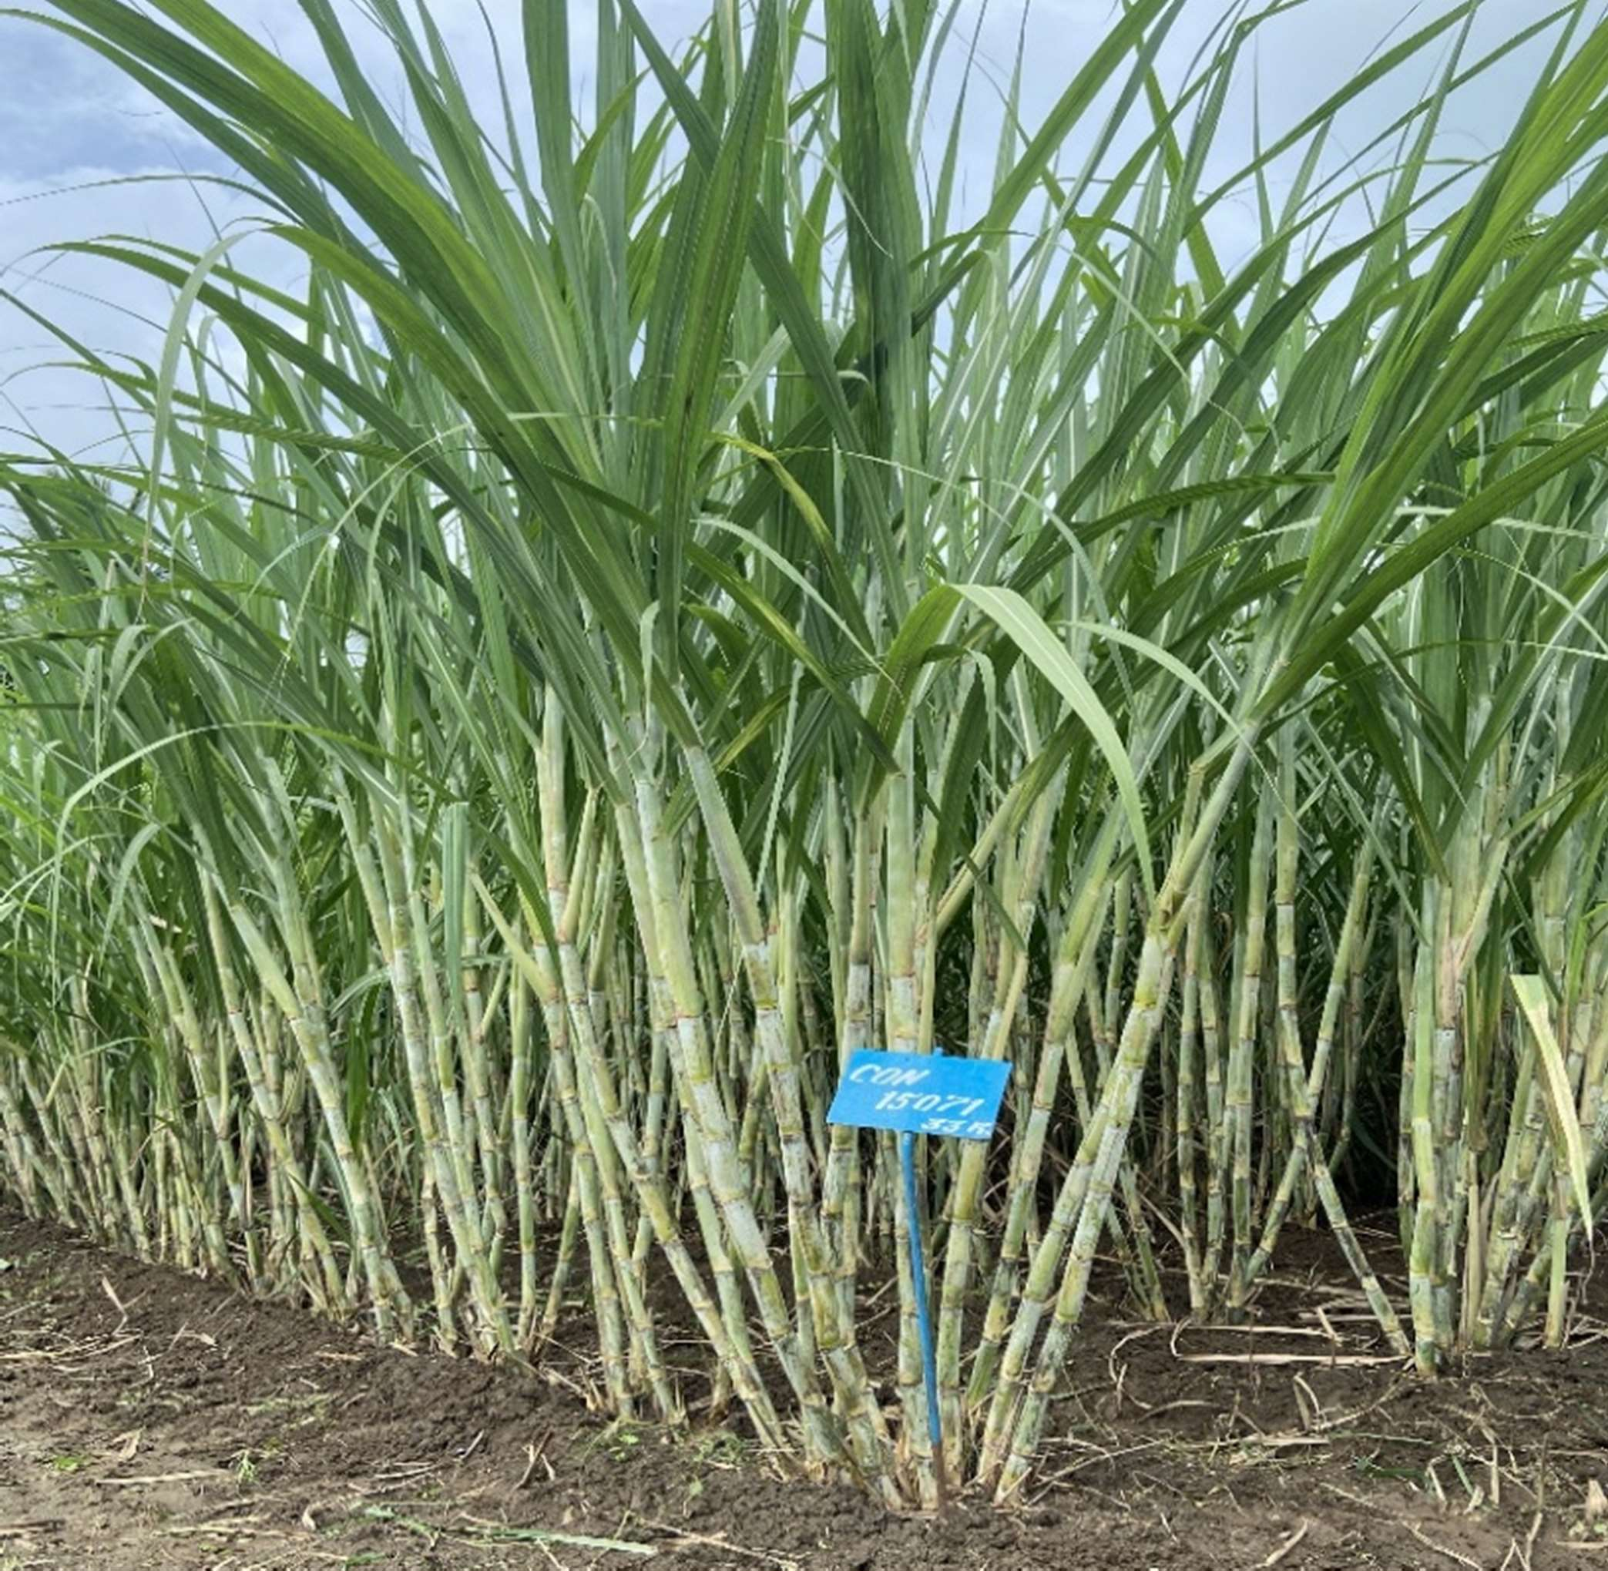 | Particulars | Characteristics
 | Parents | CoM 0265 X CoN 85134
 | Cane Yield (t/ha) | 129.34
 | Sugar yield (t/ha) | 16.38
 | Sucrose % Juice | 17.27
 | Disease reaction | Red rot: MR Wilt: MR Smut: R

- CoN 18071 (Gujarat Navsari Sugarcane – 13) (Madhuri) (2024)
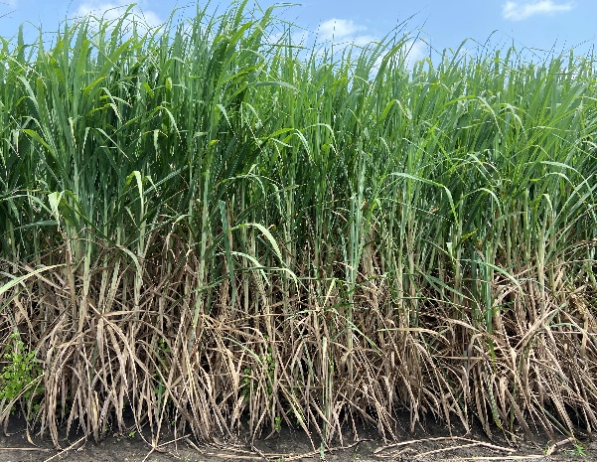 | Particulars | Characteristics
 | Parents | Co 85002 G.C.
 | Cane Yield (t/ha) | 130.47
 | Sugar yield (t/ha) | 14.40
 | Sucrose % Juice | 18.33
 | Disease reaction | Red rot: MR Wilt:MR Smut: R

  - Clones of the Centre included in National hybridization Garden, SBI Coimbatore

CoN 91132 | CoN 05071 | *CoN 13072 | *CoN 18071
CoN 05072 | CoN 95132 | *CoN 13073
CoN 07072 |  | *CoN 15071

  - Centre contributed sugarcane clones for zonal testing in AICRP (S)

Year | 2021 | 2022 | 2023 | 2024 | 2025
Sugarcane Variety | CoN 21071 | 22071 | 23071 | 24071 | 25071
Sugarcane Variety | CoN 21072 | - | 23072 | 24072 | 25072
Sugarcane Variety | - | - | - | 24073 | 25073

  - Breeder Seed distributed for further multiplication

Year | Sugarcane Seed  (t/ha)
2021-22 | 488
2022-23 | 362
2023-24 | 388
2024-25 | 375
2025-26 | 310.37
1.5 Single eye bud settling production as per farmer need

Year | Single eye bud plantlets
2021-22 | 124514
2022-23 | 274300
2023-24 | 318035
2024-25 | 248480
2025-26 | 200800

2. Production and Protection technology developed (2021 to 2025)
2.1: Agronomy
Two sugarcane production technologies were developed and recommended to farmers of South Gujarat heavy rainfall zone AES-III.

2.1.1: Recommendation for farmer’s community

1. Assessment of planting geometry for single eye budded settling on sugarcane under south Gujarat condition (2022-23).
The farmers of south Gujarat planting sugarcane through single eye bud settling are recommended to plant the settling at 120 cm row spacing or with pair row of 60-120-60 cm. Further, it is also recommended to keep plant to plant distance 45 cm for getting higher yield and net return.
2. Effect of nutrient management on sugarcane planted through single eye budded settling under south Gujarat condition (2023-24).
The farmers of south Gujarat planting sugarcane crop through single eye bud settling are recommended to apply FYM 25 t/ha or bio compost 15 t/ha and to fertilize the crop with 188-94-94 kg N-P2O5-K2O/ha (Nitrogen in four splits @ 15 % at basal, 30 % at 1.5 month after planting, 20 % at 3 month after planting and 35 % at 5 month after planting) along with bio fertilizer application (Acetobacter + Phosphate solubilizing bacteria(PSB) + Potash mobilizing bacteria(KMB) applied two times as basal and before final earthing up @ 2.5 l/ha each both time) for saving 25 % fertilizer dose.

2.2: Plant Pathology
2.2.1. Recommendation for scientific community

2020-21
- Sugarcane varieties viz., Co 13003, Co 13004, CoN 13072, CoSnk 13101, MS 13081, Co 13006, Co 13009, Co 13013, CoN 13073 and CoSnk 13103 were found moderately resistant against red rot disease.
- Sugarcane varieties viz., Co 13002, Co 13003, MS 13081, Co 13008, Co 13009, Co 13013, Co 13018 and CoN 13073 were found resistant whereas Co 13004, CoN 13072 and Co 13020 were exhibited moderately resistant whip smut disease.

