 | Department of Fruit Science  ASPEE College of Horticulture  Navsari Agricultural University,  Navsari – 396 450 |  | 
Faculty Profile
....
Profile of Dr. D. K. Sharma
Designation |  |  |  | : | Professor and Head |  |  |  |  |  |  |  | 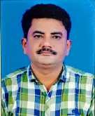
Qualification |  |  |  | : | Ph.D. Horticulture
Specialization |  |  |  | : | Fruit Science
Phone No. (Office) |  |  |  | : | 02637-282144(661)
Mob. No. |  |  |  | : | +91 8128988972
e-mail |  |  |  | : | dksharma@nau.in
Professional Experience |  |  |  | : | 26 years
PG students guided |  |  |  | : | M.Sc.:12and Ph.D.:3
Publications
1 | Research articles | : | 25 |  |  |  | 5 |  | Booklet |  |  |  |  | : | 02
2 | Popular articles | : | 10 |  |  |  | 6 |  | Folders/Pamphlets/Extension Bulletins |  |  |  |  | : | 10
3 | Book chapter | : | 05 |  |  |  | 7 |  | Teaching manual |  |  |  |  | : | 08
4 | Book | : | 01 |  |  |  | 8 |  | Abstract |  |  |  |  | : | 20
Awards, Medals and Recognition
SN | Name of Awards, Medals and  Recognition |  |  |  |  |  |  |  |  | Year | Awarding institute/Agency
1 | Best Poster Award |  |  |  |  |  |  |  |  | 2016 | The Horticultural Society of India
Research project on hand in which working as PI/Co-PI |  |  |  |  |  |  |  |  |  |  |  | PI:1Co-PI:2
Research project completed in which worked as PI/Co-PI |  |  |  |  |  |  |  |  |  |  |  | PI:8Co-PI:10
Number of Recommendations/Messages
1 | For farmers community |  |  |  |  |  |  |  | : |  | 5
2 | For Scientific community |  |  |  |  |  |  |  | : |  | 1
3 | For Policymakers/ extension  personnel |  |  |  |  |  |  |  | : |  | 0
Number of Seminar/Conference/Workshop/Training/Convention attended
1 | Seminar |  |  |  |  |  |  |  | : |  | 12
2 | 21daystraining |  |  |  |  |  |  |  | : |  | 2
3 | conference |  |  |  |  |  |  |  | : |  | 10
4 | Workshop |  |  |  |  |  |  |  | : |  | 5
Additional charges handling |  |  |  |  |  | : |  | 1.Professor and Head, PSMA Department

Profile of Dr. B. M. Tandel
Designation |  |  |  | : | Associate Professor |  |  |  |  |  |  |  |  |  | 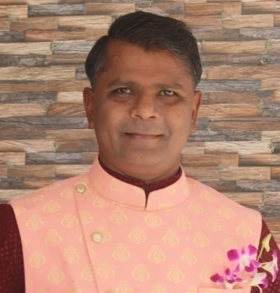
Qualification |  |  |  | : | Ph. D. (Horti) in Fruit Science
Specialization |  |  |  | : | Mango, Sapota, Dragon fruit
Phone No. (Office) |  |  |  | : | +91 2637 282144 Ext 669
Mob. No. |  |  |  | : | 9427125979
e-mail |  |  |  | : | hariombhupi@nau.in
Professional Experience |  |  |  | : | 17 years
PG students guided |  |  |  | : | M.Sc.: 11 and Ph. D.: 0
Publications
1 | Research articles | : | 56 |  |  |  |  |  | 5 |  | Booklet |  |  |  |  | : | 00
2 | Popular articles | : | 75 |  |  |  |  |  | 6 |  | Folders/Pamphlets/Extension Bulletins |  |  |  |  | : | 26
3 | Book chapter | : | 00 |  |  |  |  |  | 7 |  | Teaching manual |  |  |  |  | : | 01
4 | Book | : | 14 |  |  |  |  |  | 8 |  | Abstract |  |  |  |  | : | 43
Awards, Medals and Recognition
SN | Name of Awards, Medals and Recognition |  |  |  |  |  |  |  |  | Year |  |  | Awarding institute/ Agency
1 | Mahindra Smriddhi India Agri award, Krishi Vigyan Kendra Samman runner up award winner |  |  |  |  |  |  |  |  | 2014 |  |  | Mahindra and Mahindra and Zee news
2 | Best poster presentation |  |  |  |  |  |  |  |  | 2009 |  |  | National seminar, NAU, Waghai
Research project on hand in which working as PI / Co-PI |  |  |  |  |  |  |  |  |  |  |  |  |  | PI : 3 Co-PI: 3
Research project completed in which worked as PI/ Co-PI |  |  |  |  |  |  |  |  |  |  |  |  |  | PI : 1 Co-PI: 0
Number of Recommendations / Messages
1 | For farmers community |  |  |  |  |  |  |  |  |  | : | 6
2 | For Scientific community |  |  |  |  |  |  |  |  |  | : | 4
3 | For Policy makers/ extension personnel |  |  |  |  |  |  |  |  |  | : | 0
Number of Seminar/Conference/Workshop/Training/Convention attended
1 | Seminar |  |  |  |  |  |  |  |  |  | : | 24
2 | 21 days training |  |  |  |  |  |  |  |  |  | : | 2
3 | conference |  |  |  |  |  |  |  |  |  | : | 2
Additional charges handling |  |  |  |  |  | : |  | 1. I/C. Research Scientist, RHRS, ACH, NAU, Navsari

Profile of Dr. R. V. Tank
Designation |  |  |  | : | Associate Professor |  |  |  |  |  |  |  |  |  | 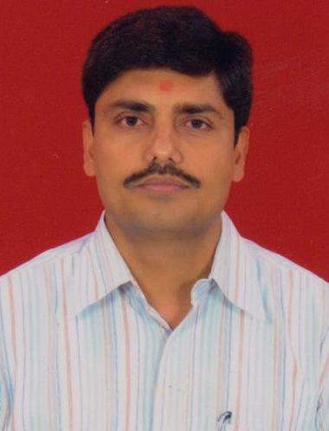
Qualification |  |  |  | : | Ph. D.
Specialization |  |  |  | : | Horticulture (Fruit Science)
Phone No. (Office) |  |  |  | : | 02637 282144 Ext. 667
Mob. No. |  |  |  | : | 9426837531
e-mail |  |  |  | : | rameshtank@nau.in
Professional Experience |  |  |  | : | 29 years
PG students guided |  |  |  | : | M.Sc.: 12 and Ph. D.: 2
Publications
1 | Research articles | : | 32 |  |  |  |  |  | 5 |  | Booklet |  |  |  |  | : | 03
2 | Popular articles | : | 06 |  |  |  |  |  | 6 |  | Folders/Pamphlets/Extension Bulletins |  |  |  |  | : | 00
3 | Book chapter | : | 07 |  |  |  |  |  | 7 |  | Teaching manual |  |  |  |  | : | 04
4 | Book | : | 01 |  |  |  |  |  | 8 |  | Abstract |  |  |  |  | : | 11
Awards, Medals and Recognition
SN | Name of Awards, Medals and Recognition |  |  |  |  |  |  |  |  | Year |  |  | Awarding institute/ Agency
1 | Best Poster Presentation Award for Effect of organics and chemicals on germination and growth parameters on mango (Mangifera indica L.) stones. |  |  |  |  |  |  |  |  | 2013 |  |  | Horticultural Society of Gujarat, Navsari
2 | Appreciation award for Global Conference on Technological Challenges and Human Resources for Climate Smart Horticulture Issues and Strategies |  |  |  |  |  |  |  |  | 2014 |  |  | ASM Foundation,NAU,CHAI
3 | Best Poster AwardMutation breeding: An approach for variability in fruit crops |  |  |  |  |  |  |  |  | 2020 |  |  | Society for Horticultural Research and Development
4 | Certificate of appreciation as co-chairman in 3 days International conference on Impact of climate changes on global food, livestock, livelihood and environmental security : Advanced approaches and mitigation strategies. |  |  |  |  |  |  |  |  | 2023 |  |  | NADCL, Baramulla, CAAST, NAU, Navsari
Research project on hand in which working as PI / Co-PI |  |  |  |  |  |  |  |  |  |  |  |  |  | PI : 1 Co-PI: 0
Research project completed in which worked as PI/ Co-PI |  |  |  |  |  |  |  |  |  |  |  |  |  | PI : 1 Co-PI: 3
Number of Recommendations / Messages
1 | For farmers community |  |  |  |  |  |  |  |  |  | : | 2
2 | For Scientific community |  |  |  |  |  |  |  |  |  | : | 1
3 | For Policy makers/ extension personnel |  |  |  |  |  |  |  |  |  | : | 0
Number of Seminar/Conference/Workshop/Training/Convention attended
1 | Seminar |  |  |  |  |  |  |  |  |  | : | 29
2 | 21 days training |  |  |  |  |  |  |  |  |  | : | 2
3 | conference |  |  |  |  |  |  |  |  |  | : | 1
4 | Workshop |  |  |  |  |  |  |  |  |  | : | 3
Additional charges handling |  |  |  |  |  | :

Profile of Dr. S. Y. Patel
Designation |  |  |  | : | Associate Professor |  |  |  |  |  |  |  |  |  | 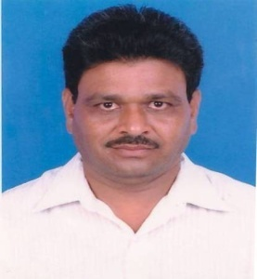
Qualification |  |  |  | : | Ph. D. (Hort.)
Specialization |  |  |  | : | Vegetable Science
Phone No. (Office) |  |  |  | : | 02637-282144
Mob. No. |  |  |  | : | +91 6354900025
e-mail |  |  |  | : | suresh@nau.in
Professional Experience |  |  |  | : | > 29 years
PG students guided |  |  |  | : | M.Sc.: 07 and Ph. D.: 0
Publications
1 | Research articles | : | 06 |  |  |  |  |  | 5 |  | Booklet |  |  |  |  | : | 01
2 | Popular articles | : | 02 |  |  |  |  |  | 6 |  | Folders/Pamphlets/Extension Bulletins |  |  |  |  | : | 01
3 | Book chapter | : | 00 |  |  |  |  |  | 7 |  | Teaching manual |  |  |  |  | : | 00
4 | Book | : | 00 |  |  |  |  |  | 8 |  | Abstract |  |  |  |  | : | 06
Awards, Medals and Recognition
SN | Name of Awards, Medals and Recognition |  |  |  |  |  |  |  |  | Year |  |  | Awarding institute/ Agency
1
Research project on hand in which working as PI / Co-PI |  |  |  |  |  |  |  |  |  |  |  |  |  | PI : 0Co-PI: 0
Research project completed in which worked as PI/ Co-PI |  |  |  |  |  |  |  |  |  |  |  |  |  | PI : 2 Co-PI: 1
Number of Recommendations / Messages
1 | For farmers community |  |  |  |  |  |  |  |  |  | : | 11
2 | For Scientific community |  |  |  |  |  |  |  |  |  | : | 0
3 | For Policy makers/ extension personnel |  |  |  |  |  |  |  |  |  | : | 0
Number of Seminar/Conference/Workshop/Training/Convention attended
1 | Seminar |  |  |  |  |  |  |  |  |  | : | 10
2 | 21 days training |  |  |  |  |  |  |  |  |  | : | 2
3 | Workshop |  |  |  |  |  |  |  |  |  | : | 2
Additional charges handling |  |  |  |  |  | : |  | 1. Act as signature authority on account bills on behalf of  principal, ACH, NAU, Navsari

Profile of Dr. Y. N. Tandel
Designation |  |  |  | : | Associate Professor (FS) |  |  |  |  |  |  |  |  |  | 
Qualification |  |  |  | : | Ph. D., NET, ARS (2009)
Specialization |  |  |  | : | Fruit Science
Phone No. (Office) |  |  |  | : | 02637-282144 Ext. 618
Mob. No. |  |  |  | : | 09601283385
e-mail |  |  |  | : | yatintandel1512000@nau.in
Professional Experience |  |  |  | : | 15 years
PG students guided |  |  |  | : | M.Sc.: 14 and Ph. D.: 02
Publications
1 | Research articles | : | 55 |  |  |  |  |  | 5 |  | Booklet |  |  |  |  | : | 02
2 | Popular articles | : | 60 |  |  |  |  |  | 6 |  | Folders/Pamphlets/Extension Bulletins |  |  |  |  | : | 20
3 | Book chapter | : | 09 |  |  |  |  |  | 7 |  | Teaching manual |  |  |  |  | : | 03
4 | Book | : | 09 |  |  |  |  |  | 8 |  | Abstract |  |  |  |  | : | 50
Awards, Medals and Recognition
SN | Name of Awards, Medals and Recognition |  |  |  |  |  |  |  |  | Year |  |  | Awarding institute/ Agency
1 | Best Ph. D. Thesis- 2011 |  |  |  |  |  |  |  |  | 2012 |  |  | The Gujarat Association for Agricultural Sciences (GAAS), Ahmedabad
2 | Best Article Award |  |  |  |  |  |  |  |  | 2021 |  |  | Agriculture & Food: e-Newsletter (2021)
3
Research project on hand in which working as PI / Co-PI |  |  |  |  |  |  |  |  |  |  |  |  |  | PI : 1 Co-PI: 2
Research project completed in which worked as PI/ Co-PI |  |  |  |  |  |  |  |  |  |  |  |  |  | PI : 1 Co-PI: 1
Number of Recommendations / Messages
1 | For farmers community |  |  |  |  |  |  |  |  |  | : | 18
2 | For Scientific community |  |  |  |  |  |  |  |  |  | : | 3
3 | For Policy makers/ extension personnel |  |  |  |  |  |  |  |  |  | : | 0
Number of Seminar/Conference/Workshop/Training/Convention attended
1 | Seminar |  |  |  |  |  |  |  |  |  | : | 32
2 | 21 days training |  |  |  |  |  |  |  |  |  | : | 3
3 | Conference |  |  |  |  |  |  |  |  |  | : | 5
Additional charges handling |  |  |  |  |  | : |  | 1. Expert in advisory of Gramin Krishi Mausam Sewa (GKMS) by Agricultural Meteorological Cell, Dept. of Agril. Engi., NMCA, NAU, Navsari  2. Expert in Kisan Call Center (1551) for Fruit Science discipline as Officer Level- II  3. Serving technical guidance to the farmers of South Gujarat  4. Nodal Officer of MYSY Help Centre of University  5. Nodal Officer of JRF Coaching Series in University  6. UG Academic In-charge of college

Profile of Dr. A. K. Pandey
Designation |  |  |  | : | Assistant Professor |  |  |  |  |  |  |  |  |  | 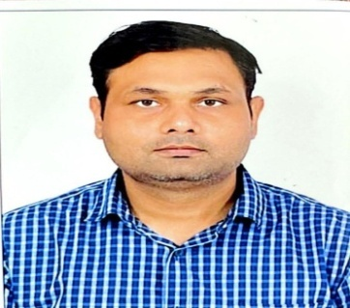
Qualification |  |  |  | : | Ph.D.
Specialization |  |  |  | : | Fruit Science
Phone No. (Office) |  |  |  | : | 02637-282144 Ext-615
Mob. No. |  |  |  | : | 9913028496
e-mail |  |  |  | : | akp15@nau.in
Professional Experience |  |  |  | : | 09 years
PG students guided |  |  |  | : | M.Sc.: 9 and Ph. D.: 0
Publications
1 | Research articles | : | 49 |  |  |  |  |  | 5 |  | Booklet |  |  |  |  | : | 00
2 | Popular articles | : | 12 |  |  |  |  |  | 6 |  | Folders/Pamphlets/Extension Bulletins |  |  |  |  | : | 00
3 | Book chapter | : | 19 |  |  |  |  |  | 7 |  | Teaching manual |  |  |  |  | : | 00
4 | Book | : | 04 |  |  |  |  |  | 8 |  | Abstract |  |  |  |  | : | 51
Awards, Medals and Recognition
SN | Name of Awards, Medals and Recognition |  |  |  |  |  |  |  |  | Year |  |  | Awarding institute/ Agency
1 | Young Scientist Award |  |  |  |  |  |  |  |  | 2017 |  |  | Venketeshwara University Tirupti Andhra Pradesh
2 | Himadri Young Scientist Award |  |  |  |  |  |  |  |  | 2023 |  |  | GBPUA&T Pantnagar & ISHRD Uttarakhand
Research project on hand in which working as PI / Co-PI |  |  |  |  |  |  |  |  |  |  |  |  |  | PI : 1 Co-PI: 1
Research project completed in which worked as PI/ Co-PI |  |  |  |  |  |  |  |  |  |  |  |  |  | PI : 0 Co-PI: 0
Number of Recommendations / Messages
1 | For farmers community |  |  |  |  |  |  |  |  |  | : | 1
2 | For Scientific community |  |  |  |  |  |  |  |  |  | : | 1
3 | For Policy makers/ extension personnel |  |  |  |  |  |  |  |  |  | : | 0
Number of Seminar/Conference/Workshop/Training/Convention attended
1 | Seminar |  |  |  |  |  |  |  |  |  | : | 7
2 | 21 days training |  |  |  |  |  |  |  |  |  | : | 2
3 | Conference |  |  |  |  |  |  |  |  |  | : | 2
4 | UGC-HRDCtraining |  |  |  |  |  |  |  |  |  | : | 1
Additional charges handling |  |  |  |  |  | : |  | 1. Farm Manager at Instructional Farm, ACH, NAU,  Navsari  2. Assistant Placement Officer ACOH  3. Assistant Rector Horticulture UG Boys Hostel

Profile of Dr. P. D. Solanki
Designation |  |  |  | : | Assistant Professor |  |  |  |  |  |  |  |  |  | 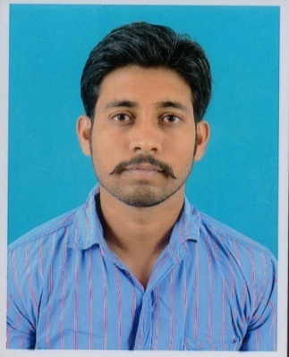
Qualification |  |  |  | : | Ph. D. (Horti.)
Specialization |  |  |  | : | Fruit Science
Phone No. (Office) |  |  |  | : | 02637-282144 extn. 625
Mob. No. |  |  |  | : | 9510551363
e-mail |  |  |  | : | pdsolanki@nau.in
Professional Experience |  |  |  | : | 08 years
PG students guided |  |  |  | : | M.Sc.: 1 and Ph. D.: 0
Publications
1 | Research articles | : | 12 |  |  |  |  |  | 5 |  | Booklet |  |  |  |  | : | 01
2 | Popular articles | : | 04 |  |  |  |  |  | 6 |  | Folders/Pamphlets/Extension Bulletins |  |  |  |  | : | 06
3 | Book chapter | : | 04 |  |  |  |  |  | 7 |  | Teaching manual |  |  |  |  | : | 00
4 | Book | : | 00 |  |  |  |  |  | 8 |  | Abstract |  |  |  |  | : | 12
Awards, Medals and Recognition
SN | Name of Awards, Medals and Recognition |  |  |  |  |  |  |  |  | Year |  |  | Awarding institute/ Agency
1 | Best Oral Presentation Award |  |  |  |  |  |  |  |  | 2017 |  |  | ASM Foundation, New Delhi and Junagadh Agricultural University, Junagadh, Gujarat
2 | Best Lead Presenter Award |  |  |  |  |  |  |  |  | 2019 |  |  | ICAR-AICRP on fruits  At Assam Agricultural University,Jorhat
3 | Young Scientist Award |  |  |  |  |  |  |  |  | 2020 |  |  | Agricultural & Environmental Technology Development Society(AETDS), U.S. Nagar, Uttarakhand, India
4 | Young Horticulturist Award |  |  |  |  |  |  |  |  | 2022 |  |  | Agricultural & Environmental Technology Development Society(AETDS), U.S. Nagar, Uttarakhand, India
5 | Distinguished Scientist Award |  |  |  |  |  |  |  |  | 2023 |  |  | National Agriculture Development Cooperative Ltd., Baramulla, UT of J & K (India)
Research project on hand in which working as PI / Co-PI |  |  |  |  |  |  |  |  |  |  |  |  |  | PI : 0Co-PI: 0
Research project completed in which worked as PI/ Co-PI |  |  |  |  |  |  |  |  |  |  |  |  |  | PI : 0 Co-PI: 1
Number of Recommendations / Messages
1 | For farmers community |  |  |  |  |  |  |  |  |  | : | 04
2 | For Scientific community |  |  |  |  |  |  |  |  |  | : | 0
3 | For Policy makers/ extension personnel |  |  |  |  |  |  |  |  |  | : | 0
Number of Seminar/Conference/Workshop/Training/Convention attended
1 | Seminar |  |  |  |  |  |  |  |  |  | : | 07
2 | 21 days training |  |  |  |  |  |  |  |  |  | : | 02
3 | Conference |  |  |  |  |  |  |  |  |  | : | 06
4 | Symposium |  |  |  |  |  |  |  |  |  | : | 02
5 | Workshop |  |  |  |  |  |  |  |  |  | : | 03
Additional charges handling |  |  |  |  |  | : |  | 1. Technical officer

Profile of Prof. Dixita D. Prajapati
Designation |  |  |  | : | Assistant Professor |  |  |  |  |  |  |  |  |  | 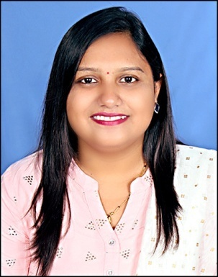
Qualification |  |  |  | : | M.Sc. (Horti.)
Specialization |  |  |  | : | Fruit Science
Phone No. (Office) |  |  |  | : | 02637-282145 Ext 666
Mob. No. |  |  |  | : | +91 9724253897
e-mail |  |  |  | : | dixitahorti@nau.in
Professional Experience |  |  |  | : | 8 years
PG students guided |  |  |  | : | M.Sc. and Ph. D.:
Publications
1 | Research articles | : | 05 |  |  |  |  |  | 5 |  | Booklet |  |  |  |  | : | 01
2 | Popular articles | : | 12 |  |  |  |  |  | 6 |  | Folders/Pamphlets/Extension Bulletins |  |  |  |  | : | 02
3 | Book chapter | : | 08 |  |  |  |  |  | 7 |  | Teaching manual |  |  |  |  | : | 00
4 | Book | : | 01 |  |  |  |  |  | 8 |  | Abstract |  |  |  |  | : | 13
Awards, Medals and Recognition
SN | Name of Awards, Medals and Recognition |  |  |  |  |  |  |  |  | Year |  |  | Awarding institute/ Agency
1 | Best PosterPresentationAward |  |  |  |  |  |  |  |  | 2014 |  |  | ASM Foundation, New Delhi and NAU, Navsari Gujarat at Global Conference onTechnological Challenges and human Resources for ClimateSmart Horticulture-Issues and Strategies
2 | Young Women Scientist Award |  |  |  |  |  |  |  |  | 2022 |  |  | Agricultural & Environmental Technology Development Society(AETDS), U.S. Nagar, Uttarakhand, India
3 | Excellence in Teaching Award |  |  |  |  |  |  |  |  | 2023 |  |  | National Agriculture Development Cooperative Ltd., Baramulla, UT of J & K (India)
4 | Best PosterPresentationAward |  |  |  |  |  |  |  |  | 2024 |  |  | ISHRD, Uttarakhand and ASPEE College of Horticulture
Research project on hand in which working as PI / Co-PI |  |  |  |  |  |  |  |  |  |  |  |  |  | PI : 3 Co-PI: 0
Research project completed in which worked as PI/ Co-PI |  |  |  |  |  |  |  |  |  |  |  |  |  | PI : 4 Co-PI: 1
Number of Recommendations / Messages
1 | For farmers community |  |  |  |  |  |  |  |  |  | : | 4
2 | For Scientific community |  |  |  |  |  |  |  |  |  | : | 0
3 | For Policy makers/ extension personnel |  |  |  |  |  |  |  |  |  | : | 0
Number of Seminar/Conference/Workshop/Training/Convention attended
1 | Seminar |  |  |  |  |  |  |  |  |  | : | 13
2 | 21 days training |  |  |  |  |  |  |  |  |  | : | 02
3 | Conference |  |  |  |  |  |  |  |  |  | : | 03
4 | Workshop |  |  |  |  |  |  |  |  |  | : | 06
5 | Webinar |  |  |  |  |  |  |  |  |  | : | 11
6 | Other training |  |  |  |  |  |  |  |  |  | : | 04
Additional charges handling |  |  |  |  |  | : |  | ---

Profile of Dr. Tulsi D. Gurjar
Designation |  |  |  | : | Assistant Professor |  |  |  |  |  |  |  |  |  | 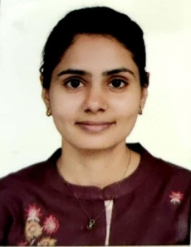
Qualification |  |  |  | : | Ph.D.
Specialization |  |  |  | : | Fruit Science
Phone No. (Office) |  |  |  | : | 02637-282144-665
Mob. No. |  |  |  | : | 9427794401
e-mail |  |  |  | : | tulsigurjar@yahoo.com
Professional Experience |  |  |  | : | 4.5 years
PG students guided |  |  |  | : | M.Sc.: 0 and Ph. D.: 0
Publications
1 | Research articles | : | 11 |  |  |  |  |  | 5 |  | Booklet |  |  |  |  | : | 00
2 | Popular articles | : | 08 |  |  |  |  |  | 6 |  | Folders/Pamphlets/Extension Bulletins |  |  |  |  | : | 00
3 | Book chapter | : | 02 |  |  |  |  |  | 7 |  | Teaching manual |  |  |  |  | : | 00
4 | Book | : | 00 |  |  |  |  |  | 8 |  | Abstract |  |  |  |  | : | 15
Awards, Medals and Recognition
SN | Name of Awards, Medals and Recognition |  |  |  |  |  |  |  |  | Year |  |  | Awarding institute/ Agency
1 | ASPEE Foundation Gold Plated Silver Medal |  |  |  |  |  |  |  |  | 2019 |  |  | Navsari Agricultural University, Navsari
2 | Kalptaru Gold Plated Silver Medal |  |  |  |  |  |  |  |  | 2019 |  |  | Navsari Agricultural University, Navsari
3 | Best Thesis Award for Ph.D. Research work |  |  |  |  |  |  |  |  | 2020 |  |  | Gujarat Association for Agricultural Science (GAAS), Ahmedabad
4 | Best Oral Presentation (Second) |  |  |  |  |  |  |  |  | 2022 |  |  | NAU, Navsari in collaboration with Indian Society for Plant Physiology, New Delhi and Climate Change Department, Government of Gujarat
5 | Best Poster Presentation (Third) |  |  |  |  |  |  |  |  | 2023 |  |  | IIHR, Bangalore
Research project on hand in which working as PI / Co-PI |  |  |  |  |  |  |  |  |  |  |  |  |  | PI : 2 Co-PI: 1
Research project completed in which worked as PI/ Co-PI |  |  |  |  |  |  |  |  |  |  |  |  |  | PI : 1 Co-PI: 0
Number of Recommendations / Messages
1 | For farmers community |  |  |  |  |  |  |  |  |  | : | 0
2 | For Scientific community |  |  |  |  |  |  |  |  |  | : | 1
3 | For Policy makers/ extension personnel |  |  |  |  |  |  |  |  |  | : | 0
Number of Seminar/Conference/Workshop/Training/Convention attended
1 | Seminar |  |  |  |  |  |  |  |  |  | : | 10
2 | 21 days training |  |  |  |  |  |  |  |  |  | : | 02
3 | Conference |  |  |  |  |  |  |  |  |  | : | 02
4 | Workshop |  |  |  |  |  |  |  |  |  | : | 01
Additional charges handling |  |  |  |  |  | : |  | ---

Supporting Technical Staff

Profile of Dr. Prasul R. Patel
Designation | : | Agriculture Officer | 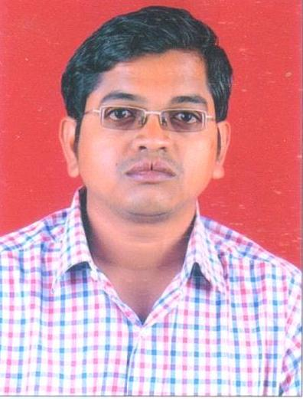
Qualification | : | Ph.D. in Horticulture
Mob. No. | : | 9879889479
e-mail | : | prpatel_1983@nau.in
Professional Experience | : | 14years
Additional charge | : | 1. Farm Manager at RHRS Farm,  ACH, NAU, Navsari

Profile of Mrs. Hemlataben K. Patel
Designation | : | Store Keeper | 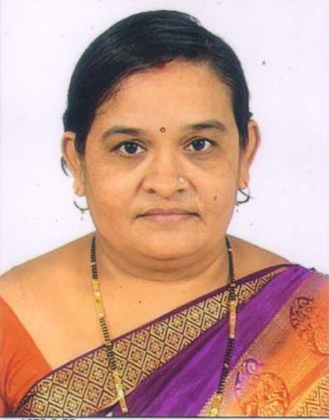
Qualification | : | Diploma (Agriculture)
Mob. No. | : | 9638839236
e-mail | : | hemapatel877@gmail.com
Professional Experience | : | 14years
Additional charge | : | --

Profile of Mr Hitesh D. Ahir
Designation | : | Agriculture Assistant | 
Qualification | : | B.Sc. (Agri.)
Mob. No. | : | 9687557212
e-mail | : | hituahir130694@gmail.com
Professional Experience | : | 7 years
Additional charge | : | Senior Clark

